MOTOTRBO radio using APRS and SMS in BrandMeister network

This example shows the settings for BrandMeister 262 Germany, in other countries it may be necessary to use another server. In Germany for APRS and messaging the address is 262999.
Note that the CPS has expert view enabled. I used CPS 13.5 EMEA to create this example.

First have a look at the general settings, to enable GPS. Depending on the GPS hardware of your radio it may be useful having a look if all satellite systems are enabled. For my DP4801e only GPS was enabled, and adding GLONASS improved time to fix quite a bit in some situations.
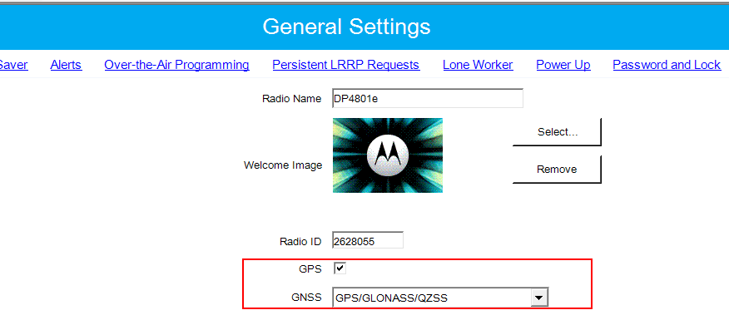

Now go to General / Persistent LRRP Request and set it like this, to make APRS transmission more reliable. It is a kind of cache to store the settings sent from the server to your radio.
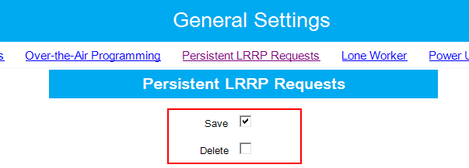
The next step is doing some network settings. Navigate to the network page and set the stuff like shown below. I do not want to go into detail, just note that that the three occurrences of 262999 may need to be adjusted to your master servers address. Not all here entered settings are necessary for APRS, but I set them to be prepared for future use, and some are needed for text messaging TMS/SMS.
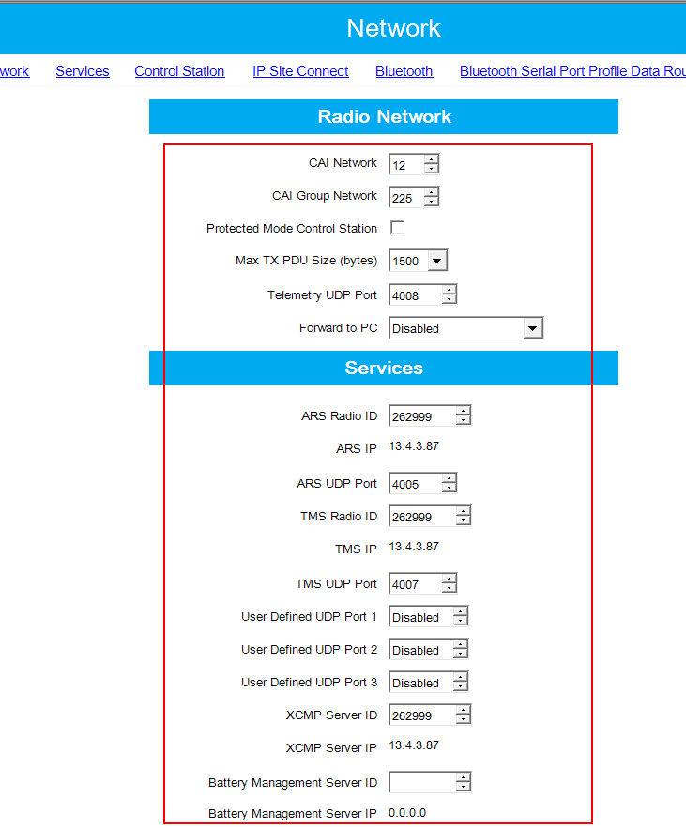

The next settings need to be made in each single channel that wants to use messaging and APRS. So you may face now some work to be done, depending on the size of your codeplug
These items from the common part of the channel data are important:
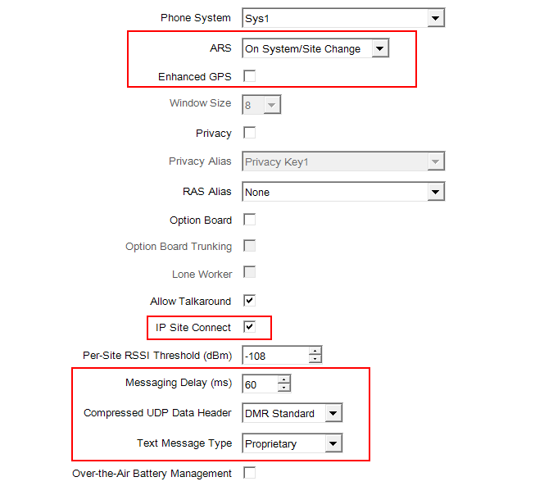

And here the stuff from the channels TX section:
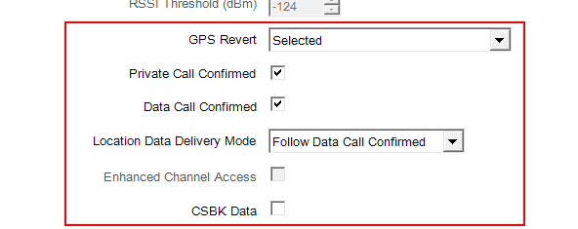
Not to forget about the BrandMeister dashboard settings! Log into your dashboard account at https://brandmeister.network and adjust your settings for all affected personal IDs, similar to this example:
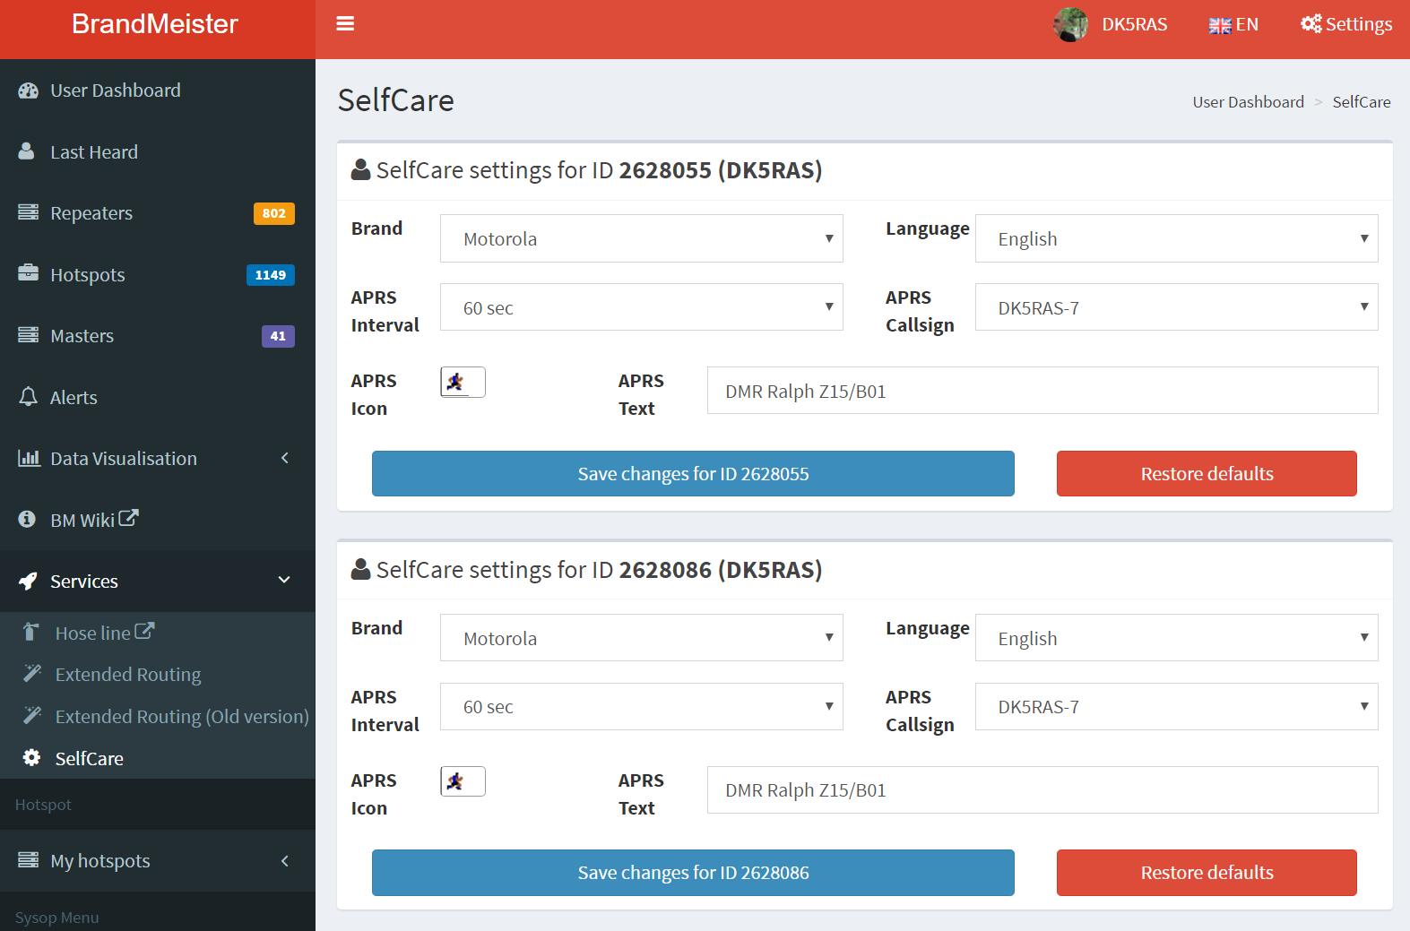

Now you should be ready to to go. Set your radio to a BrandMeister repeater or hotspot, wait for a GPS fix and watch your data showing on http://aprs.fi!

Ralph, dk5ras, ralph@schmid.xxx

